Access rights matrix for the Agents group

The need of the customer is to create a group to regroup the Agents with a retrictive use of the system. Below you will find all the requirements regarding the actual setup of Vincent (an agent).
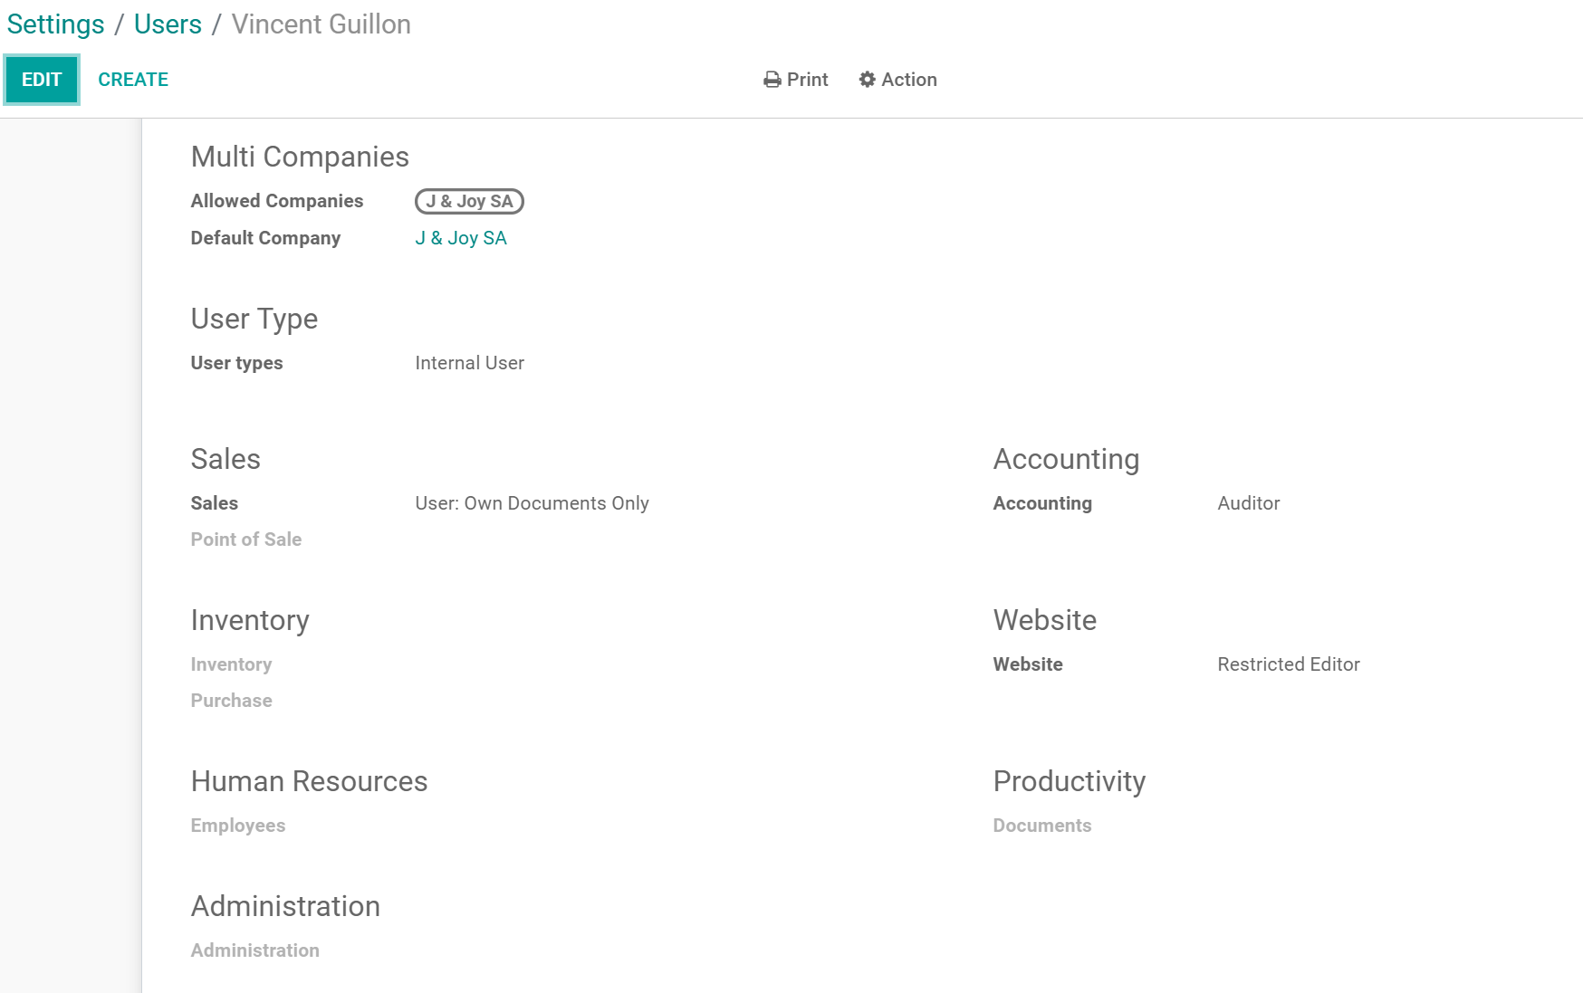

Test Agent login
Login : vincent.guillon7@wanadoo.fr
Password : Vincent4300!

noelplateau@yahoo.fr

Password : Noel4300!

Modules to display

- Only display the following 4 modules :
  - Contacts
  - Sales
  - Accounting
  - Dashboard
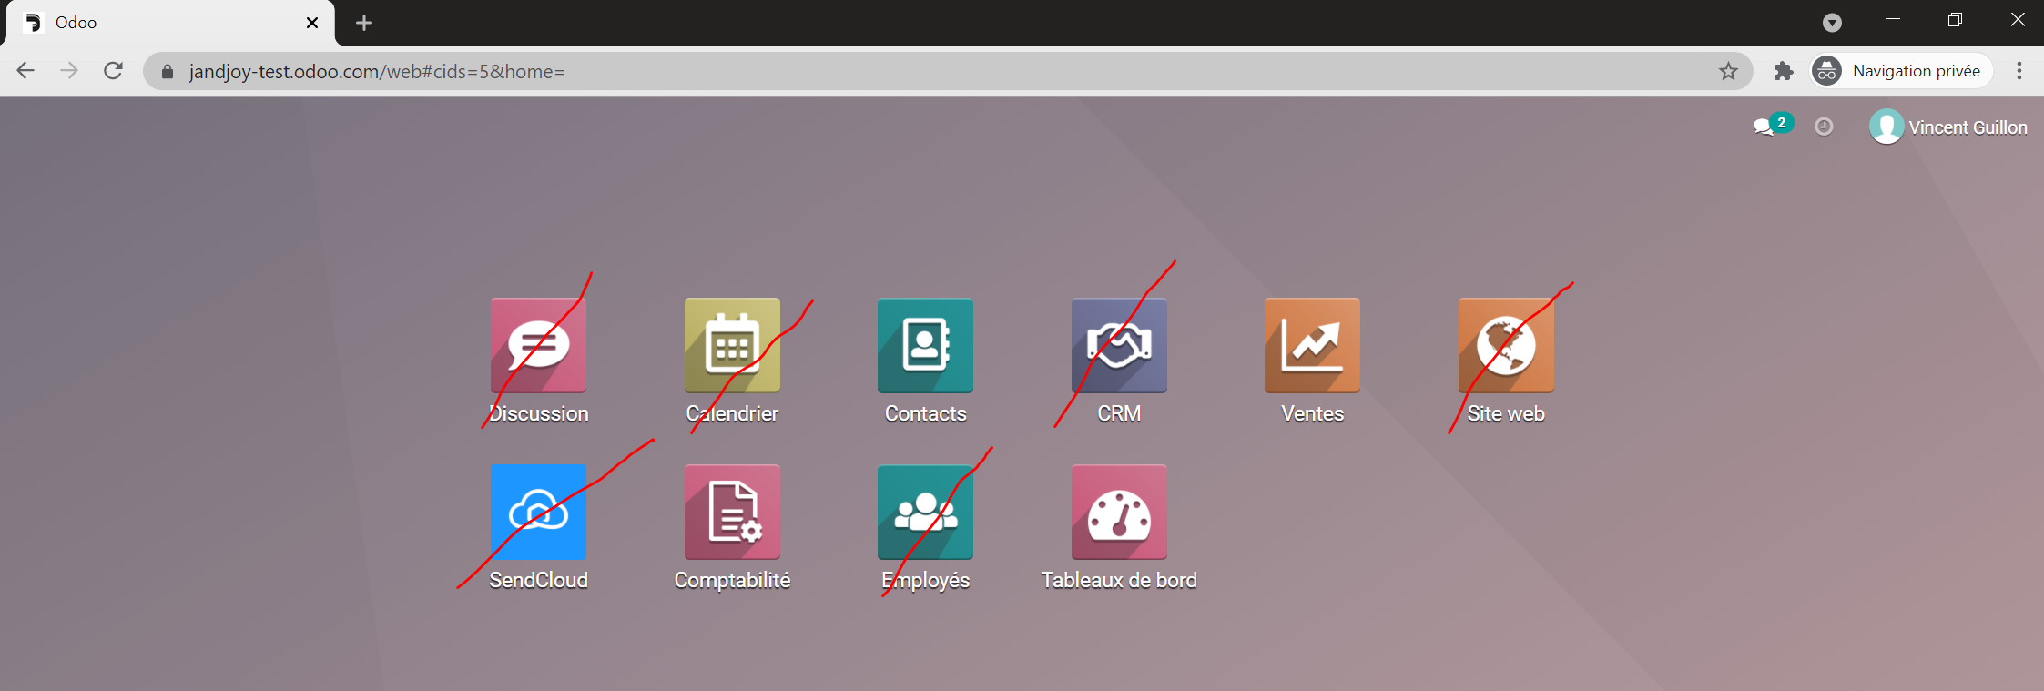

Contacts

The agent should see only the contacts where he is the Salesperson. [Domain = Salesperson]
- Accepted rights : Read, write, Update
- Disabled rights : Delete

In the contact form hide the following tab :
- Sales & Purchase
- Accounting
- Loyalty points
In tab customer status & credit limit put in read only the customer status or hide it if easier.

Sales order

- Hide all sub-tabs of products except products
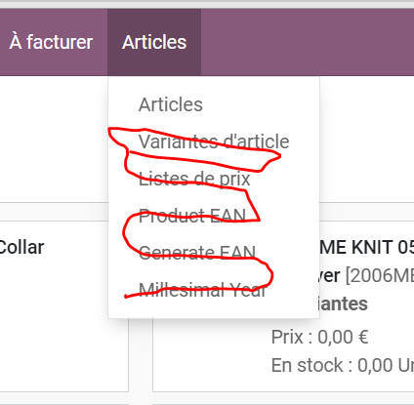

- In product form allow only a Read Only and hide all tabs after Variants. (see below) Also, hide the link to the price list ( Extra prices)
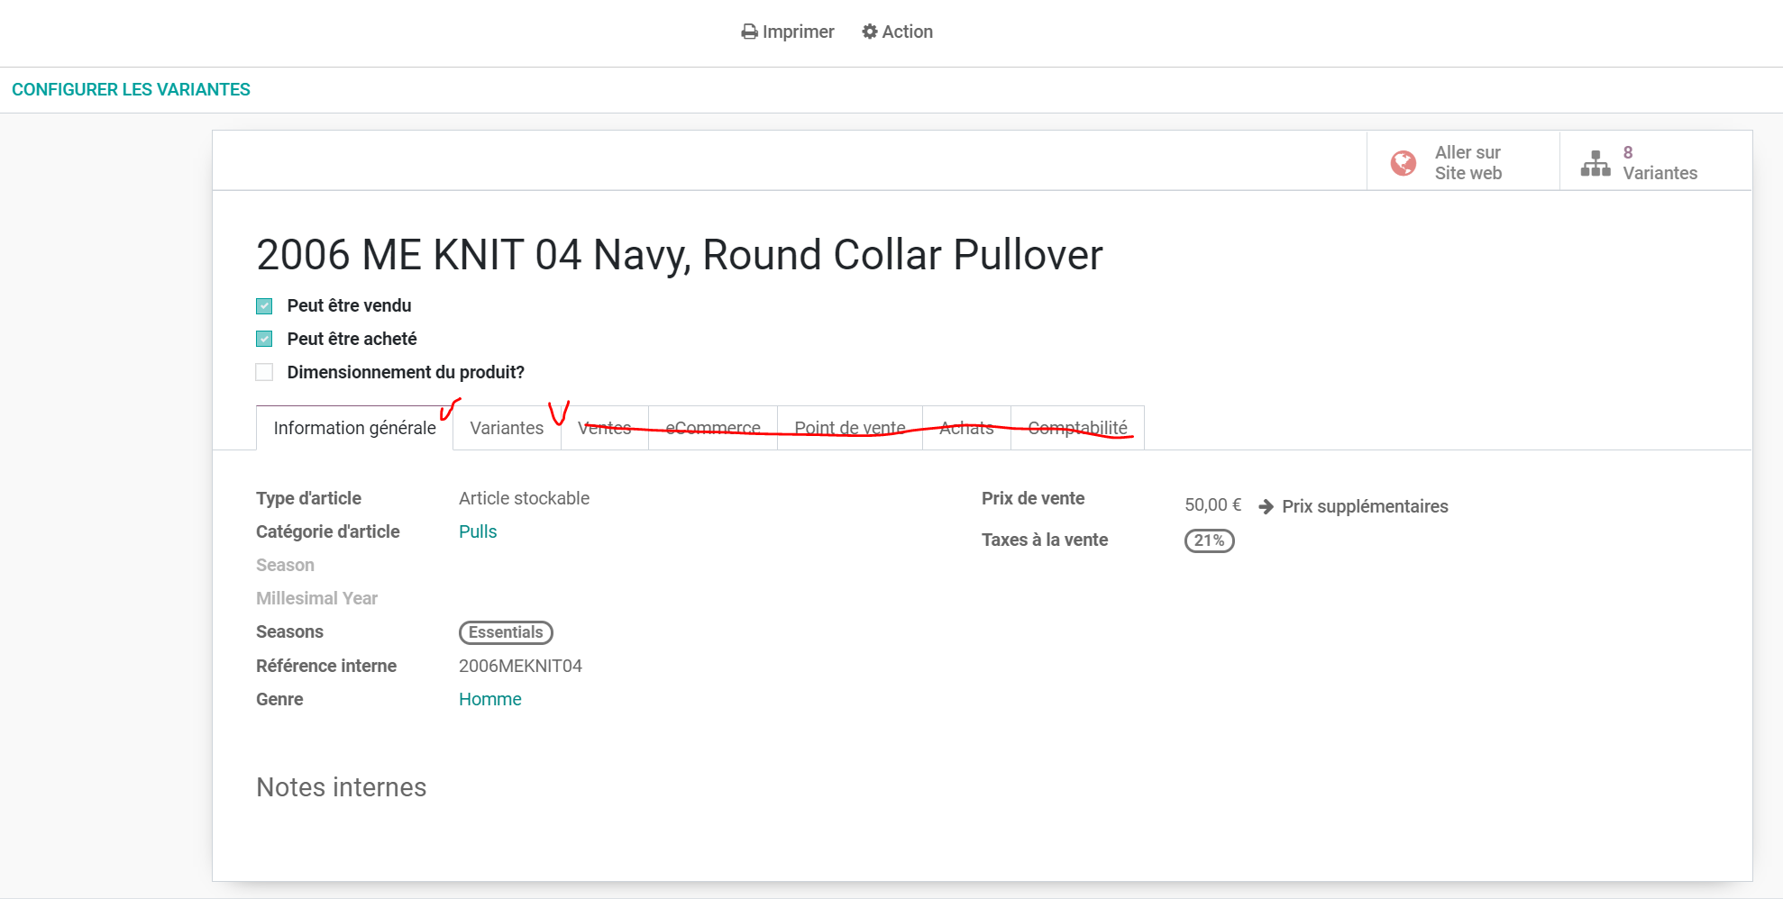

- Hide Invoices to upsell sub-menu (see in red striketrough)
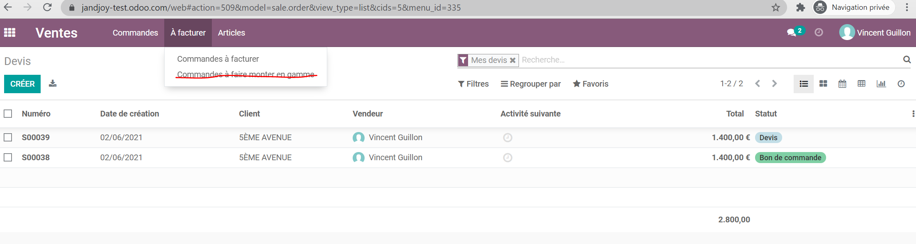

- Add a checkbox on the loyaltypoint features to deactivate the loyalty points on B2B customers. Indeed, because the agent has no rights as Sales/Adminsitrator he is not able to confirm a sales order.
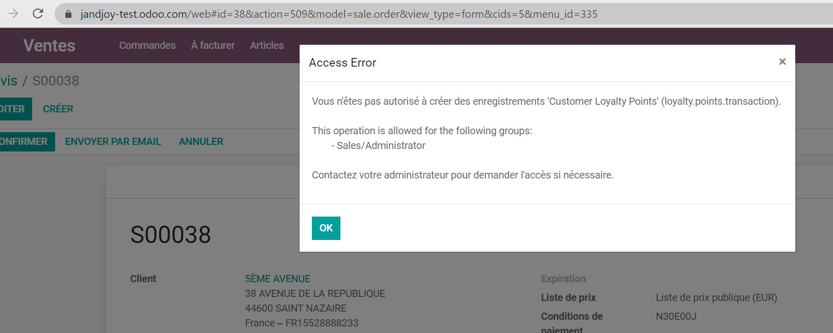
- Hide or read only the items striked through
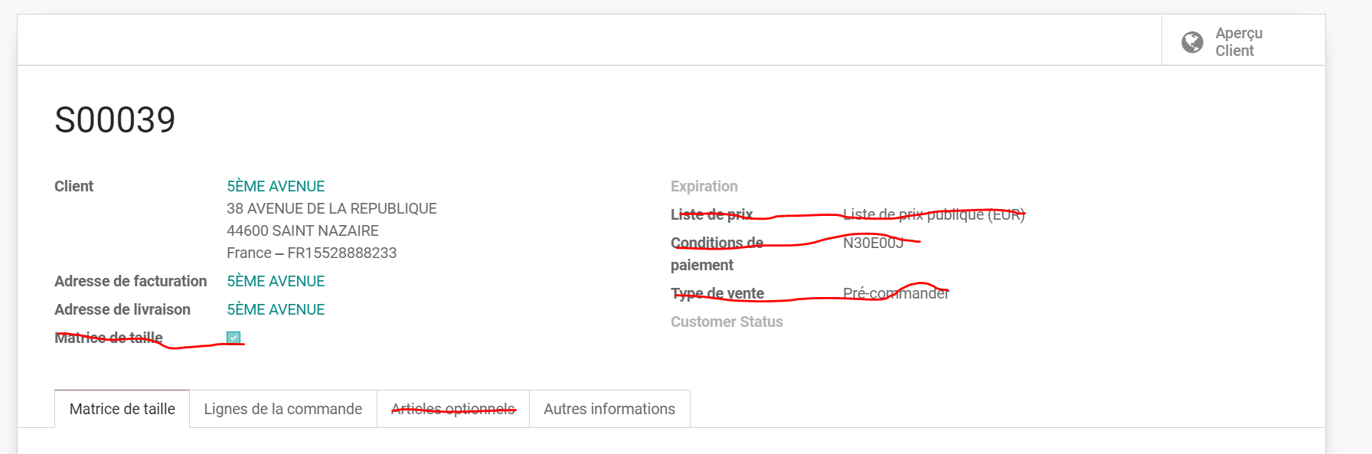
- Hide the create Invoice and cancel button from the Sales order.
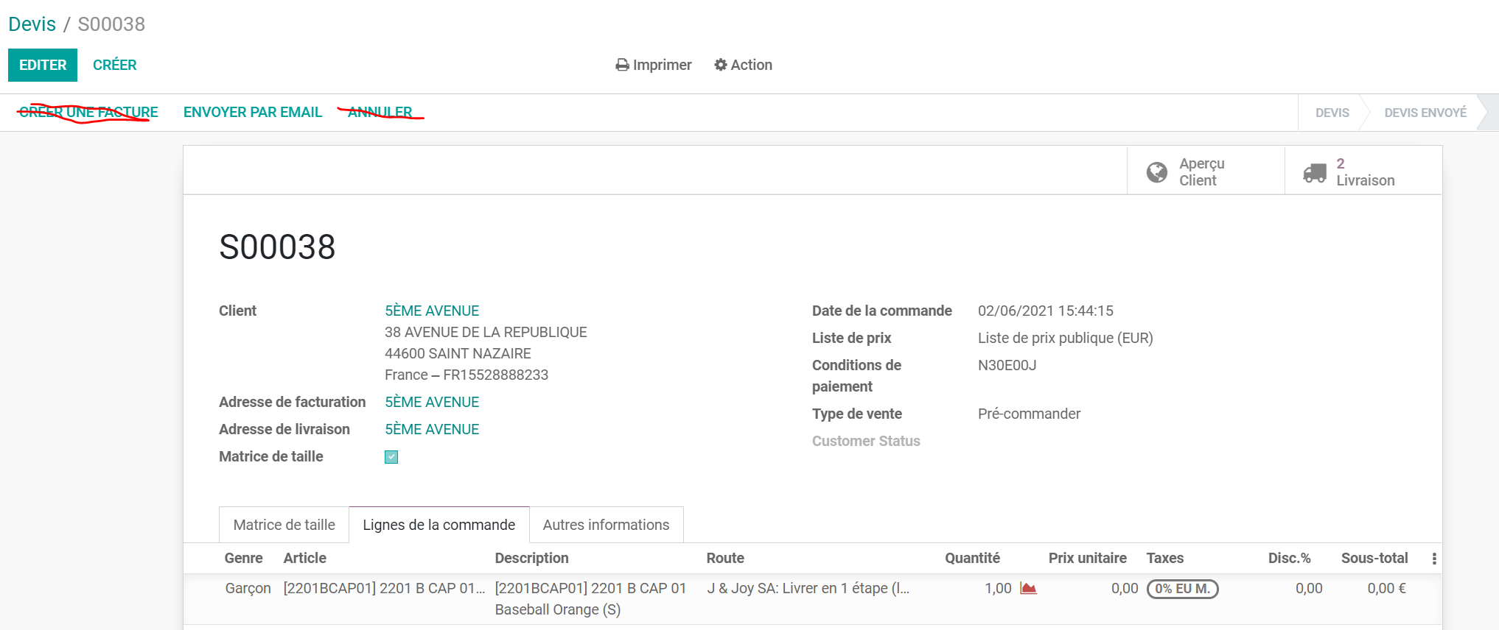

- Hide the delivery Smartbutton
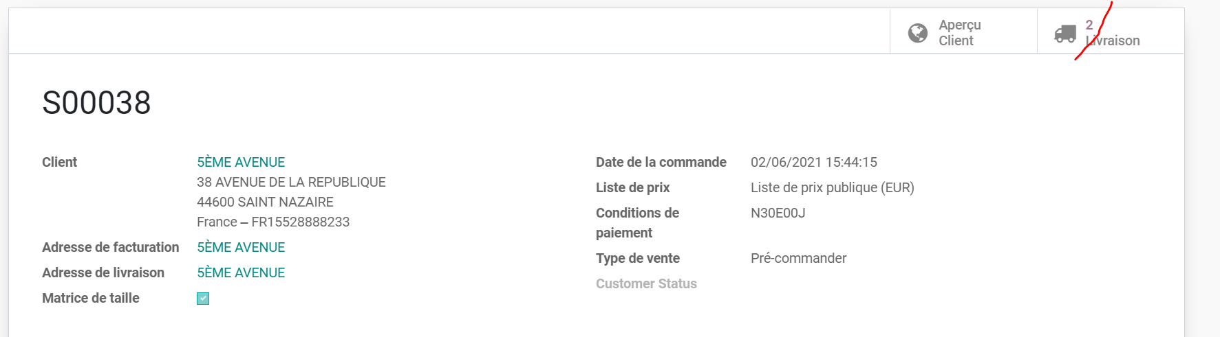

Accounting

Keep only the Customer menu and its sub-menus and filter only on invoices related to the Salesperson. [Domain = Salesperson]


